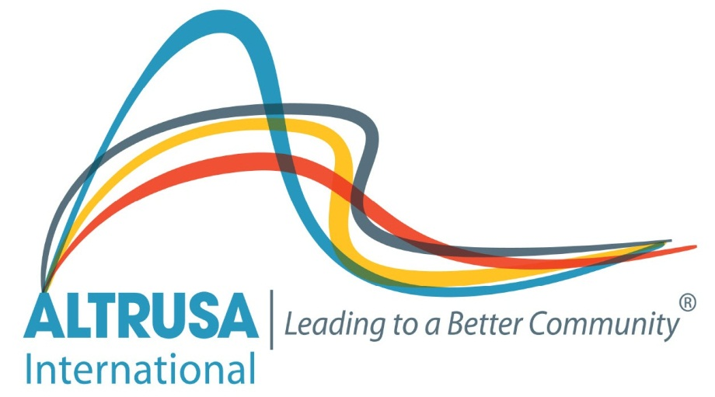

Altrusa International of Lawrence, Kansas, Inc.
Woman’s Scholarship Award – 2018
Trade/Technical/Undergraduate

Altrusa International of Lawrence, Kansas, Inc. is an organization of business and professional women who are committed to community service. This scholarship is awarded to assist a woman in achieving her career goal and financial independence. Special consideration is given to career re-entry and later career entry candidates. Because the purpose of the scholarship is to assist women in achieving a career goal, the funds may be used for books, tuition, technical equipment, transportation, and/or childcare.

A scholarship in the amount of $1000 will be awarded to the selected candidate at a meeting in May 2018.

To qualify for this scholarship, candidates must:
- Be Female
- Be enrolled or accepted by a career training or academic program located within the state of Kansas
- Be working toward a career goal
- Demonstrate financial need
- Be recommended by an instructor/faculty member
Preference is given to a resident of Douglas County.

Application materials must be postmarked by March 31, 2018. Return the completed application, along with:
- a letter explaining why you think you should be considered for the scholarship
- a resume or a list of your employment and trade/technical/academic work
- a letter of recommendation from an instructor or faculty member

You may contact Lori Michel at (785) 843-0627 or limichel@sunflower.com if you have any questions.

Send the completed materials to:

Altrusa International of Lawrence, Kansas, Inc.
Scholarship Committee
230 Concord Road
Lawrence, KS 66049

Altrusa International of Lawrence, Kansas, Inc.
Woman’s 2018 Scholarship Application
Trade/Technical/Undergraduate

Name______________________________________________________________________________________________________
Address_____________________________________________________________________________________________________
Daytime Phone ______________________________ Evening Phone __________________________Age ____________________
E-Mail Address_______________________________________________________________________________________________
Present Employment__________________________________________________________________________________________
Position__________________________________________________________ Full or Part-Time?___________________________
Number and ages of dependents _______________________________________________________________________________
Please list all others living in your home and their relationship to you ________________________________________________
____________________________________________________________________________________________________________
School/Training Program you are or will be attending______________________________________________________________
What is your educational program or plan? _______________________________________________________________________
____________________________________________________________________________________________________________
How long will it take you to complete your program or plan? ________________________________________________________
____________________________________________________________________________________________________________
How are you meeting the costs of your education? ________________________________________________________________
____________________________________________________________________________________________________________
What are your career goals? ___________________________________________________________________________________
___________________________________________________________________________________________________________
How will this scholarship help you meet those goals? ______________________________________________________________
____________________________________________________________________________________________________________
Please list your past and present contributions to your community.__________________________________________________
____________________________________________________________________________________________________________
____________________________________________________________________________________________________________
How did you hear about this scholarship? ________________________________________________________________________
Complete and send this application form to:

Altrusa International of Lawrence, Kansas, Inc., 230 Concord Road, Lawrence, KS. 66049

- Include a letter explaining why you think you should be considered for this scholarship.
- Include a resume or a list of your employment and academic work
- Include a letter of reference from an instructor or faculty member (can be mailed separately).
- All materials must be postmarked by March 31, 2018.

